Neeraj Asthana
nasthan2
CS 498: Applied Machine Learning
HW Extra Credit Report

Problem 1:
Minimum Lambda (based on lowest deviance): 0.06214394
AUC: 0.8826421
Deviance: 0.7832222
Deviance Plot:
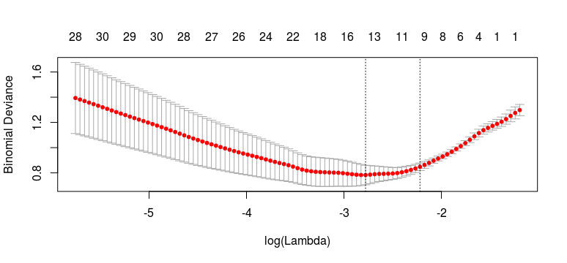
The best model uses only 14 of the 2000 genes

